Assignment 5 - CyberStart

Bradley Harper

2903-001

Challenge Name - X: Secret Caesar - HQ 1

Level of the Challenge: Easy

What was the challenge about?: Caesar Cipher

What did you learn? How to use a Caesar Cipher

Your Interest Level: Interesting

Screenshot: 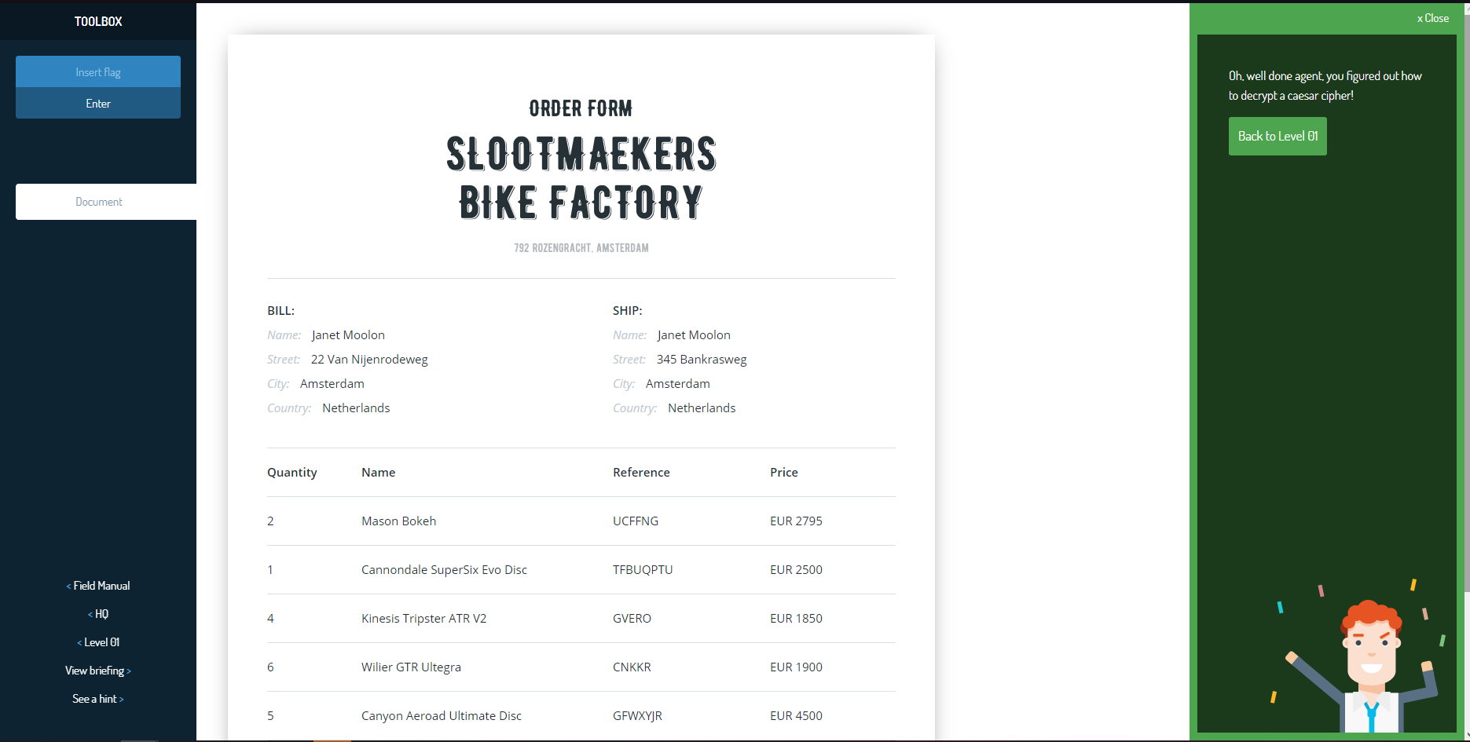

Challenge Name - X: Social Secret - HQ 2

Level of the Challenge: Easy

What was the challenge about?: Guessing age given a username

What did you learn?: Don’t use personal info in username

Your Interest Level: Not Interesting

Screenshot: 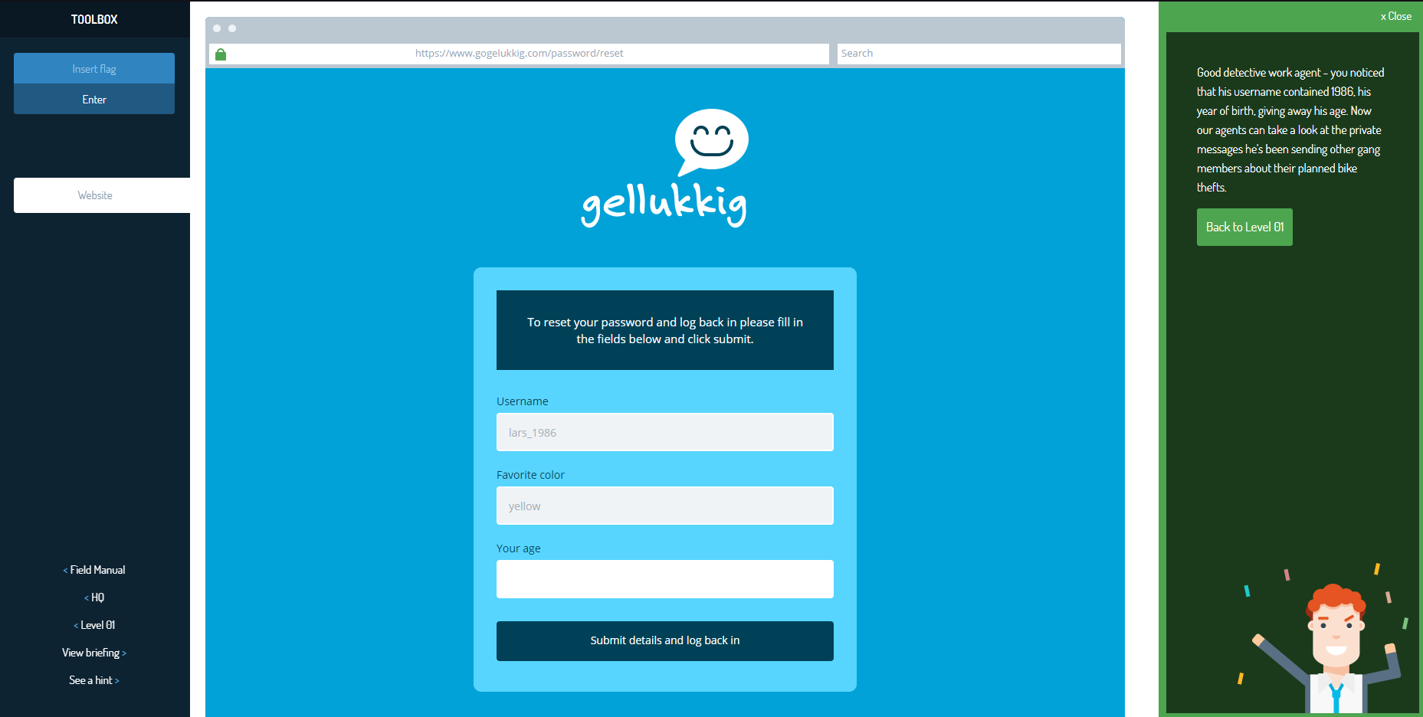

Challenge Name - X: Broken Banks - HQ 3

Level of the Challenge: Easy

What was the challenge about?: Phishing emails

What did you learn?: Check return addresses on emails

Your Interest Level: Not Interesting

Screenshot: 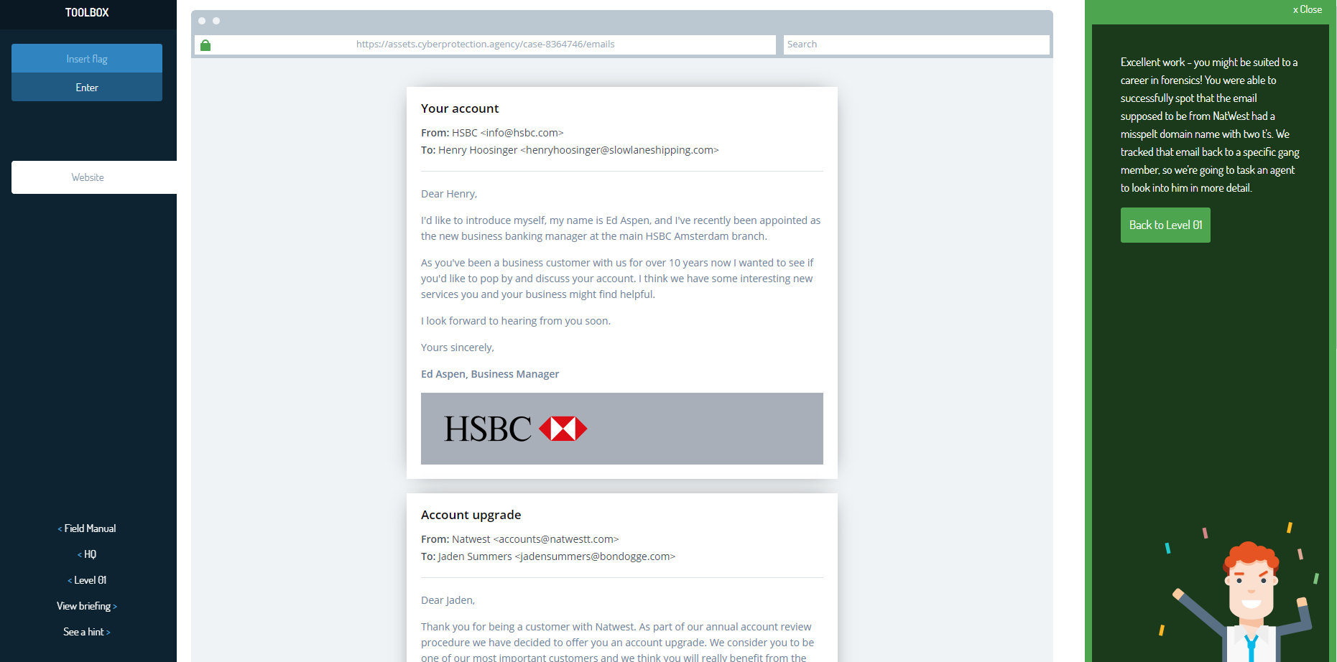

Challenge Name - X: Happy Customers - HQ 4

Level of the Challenge: Easy

What was the challenge about?: Decoding a message

What did you learn?: Decoding a message by using numeric values for letters

Your Interest Level: Not interesting

Screenshot: 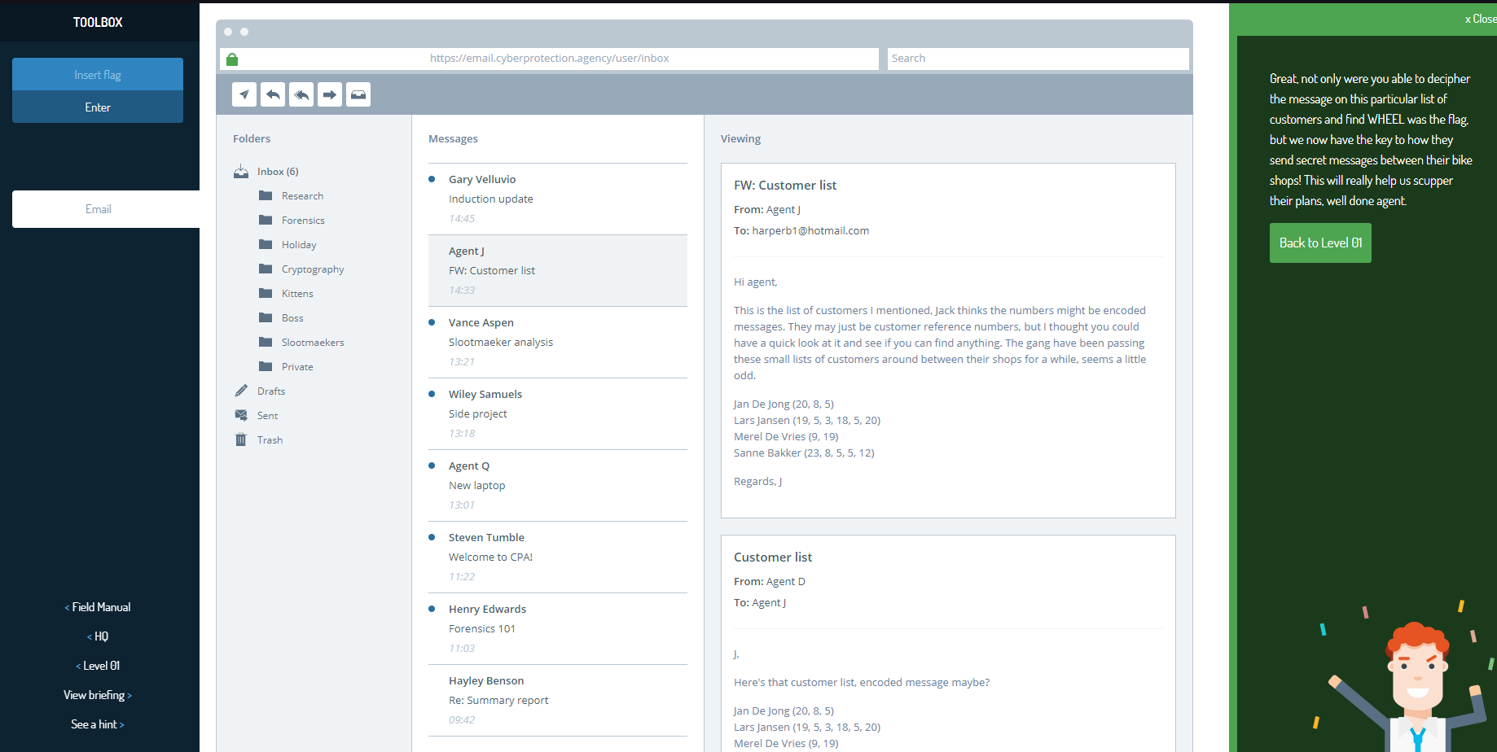

Challenge Name - X: Race To Where - HQ 5

Level of the Challenge: Easy

What was the challenge about?: Finding secret codes in html

What did you learn?: Inspect element to see hidden codes on webpage

Your Interest Level: Interesting

Screenshot: 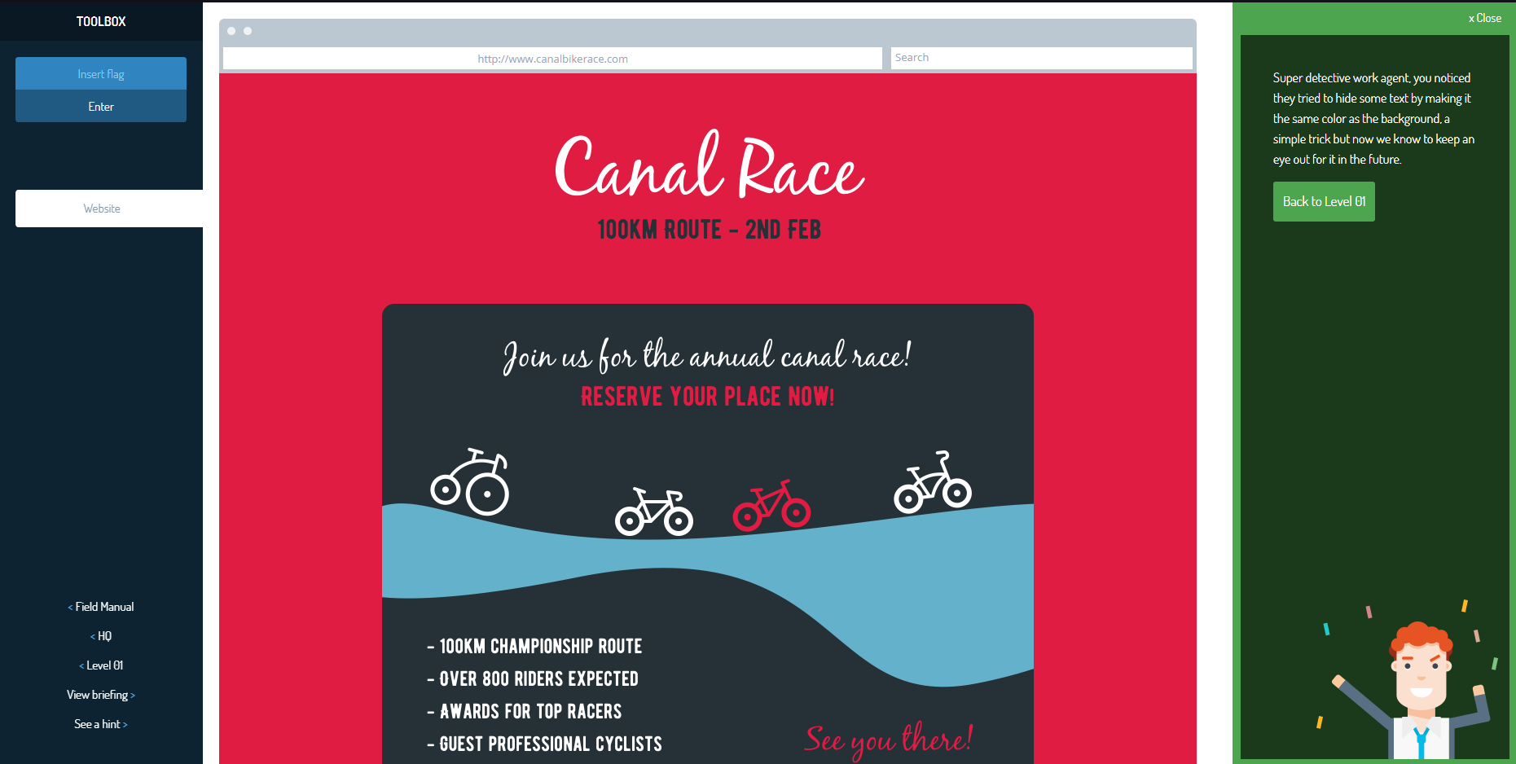

Challenge Name - X: Tower of Wheels - HQ 6

Level of the Challenge: Easy

What was the challenge about?: Tower of Hanoi Puzzle

What did you learn?: How to solve tower of hanoi puzzle

Your Interest Level: Interesting

Screenshot: 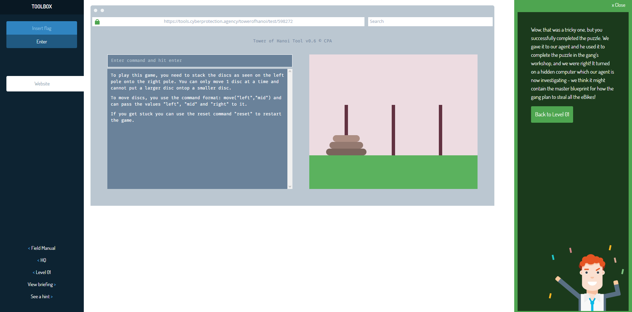

Challenge Name - X: Horrible Hats - HQ 7

Level of the Challenge: Easy

What was the challenge about?: ASCII values

What did you learn?: to read ASCII values to transcribe a code

Your Interest Level: Not interesting

Screenshot: 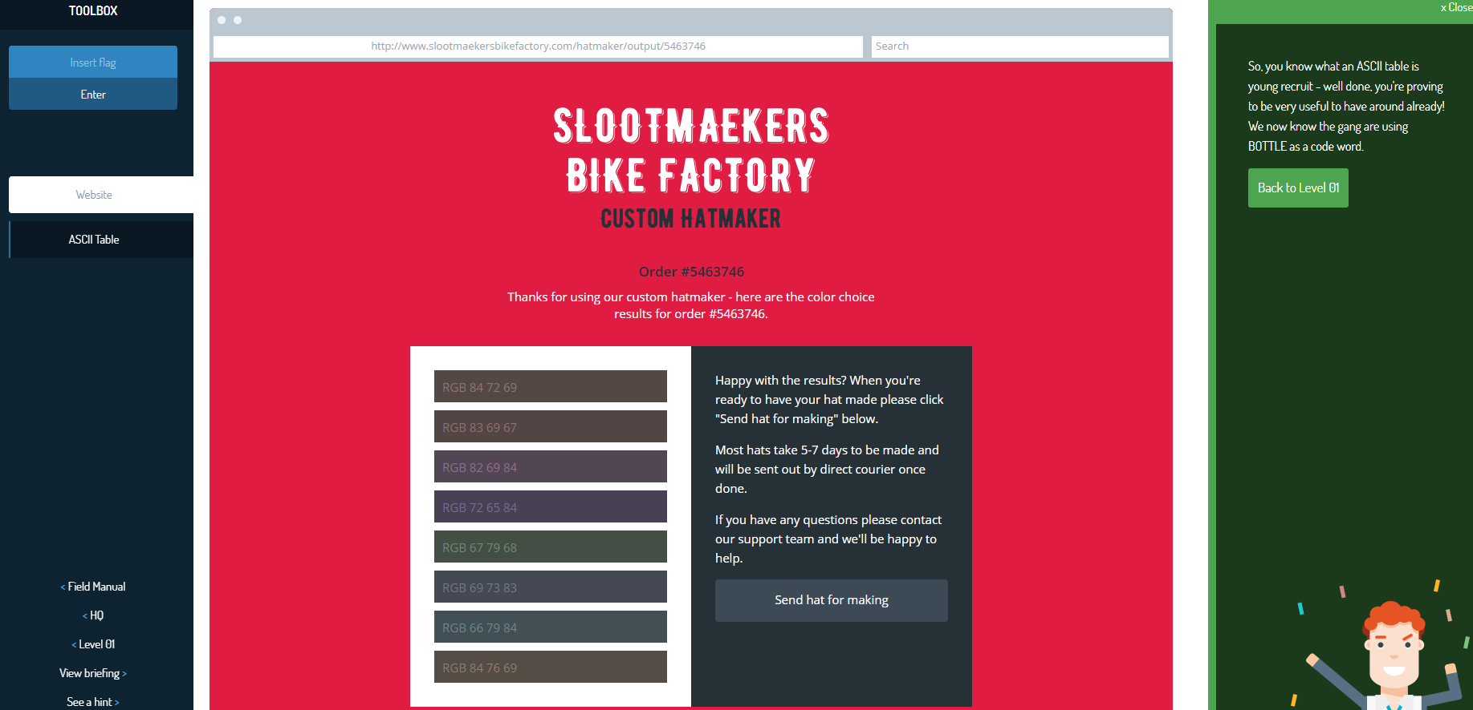

Challenge Name - X: Mixed Messages - HQ 8

Level of the Challenge: easy

What was the challenge about?: codes in scrambled words

What did you learn?: unscramble words to find code

Your Interest Level: Not interesting

Screenshot: 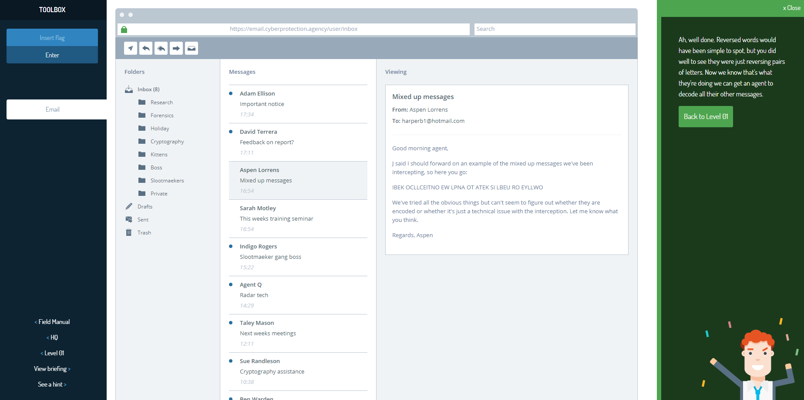

Challenge Name - X: Bike Fan - HQ 9

Level of the Challenge: Easy

What was the challenge about?: Repairing a link in a website

What did you learn?: Inspect element to fix a link to display an image

Your Interest Level: Interesting

Screenshot: 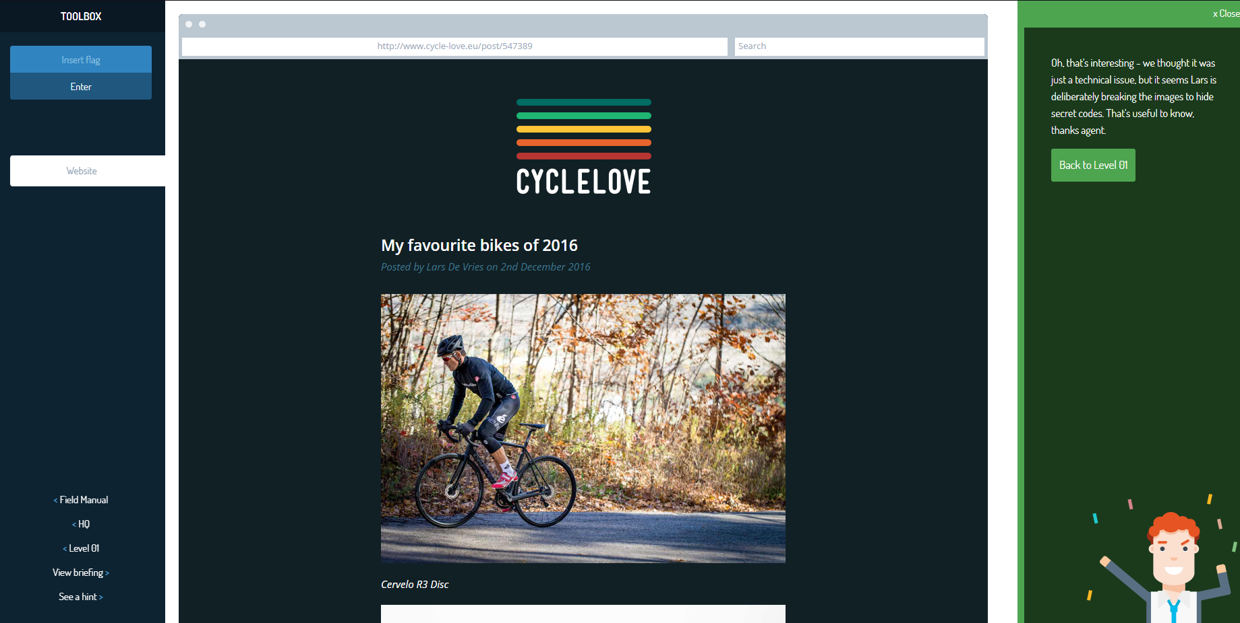

Challenge Name - X: Executable - 10

Level of the Challenge: Easy

What was the challenge about?: Picking an executable file

What did you learn?: To pick an executable file from a list

Your Interest Level: Not interesting

Screenshot: 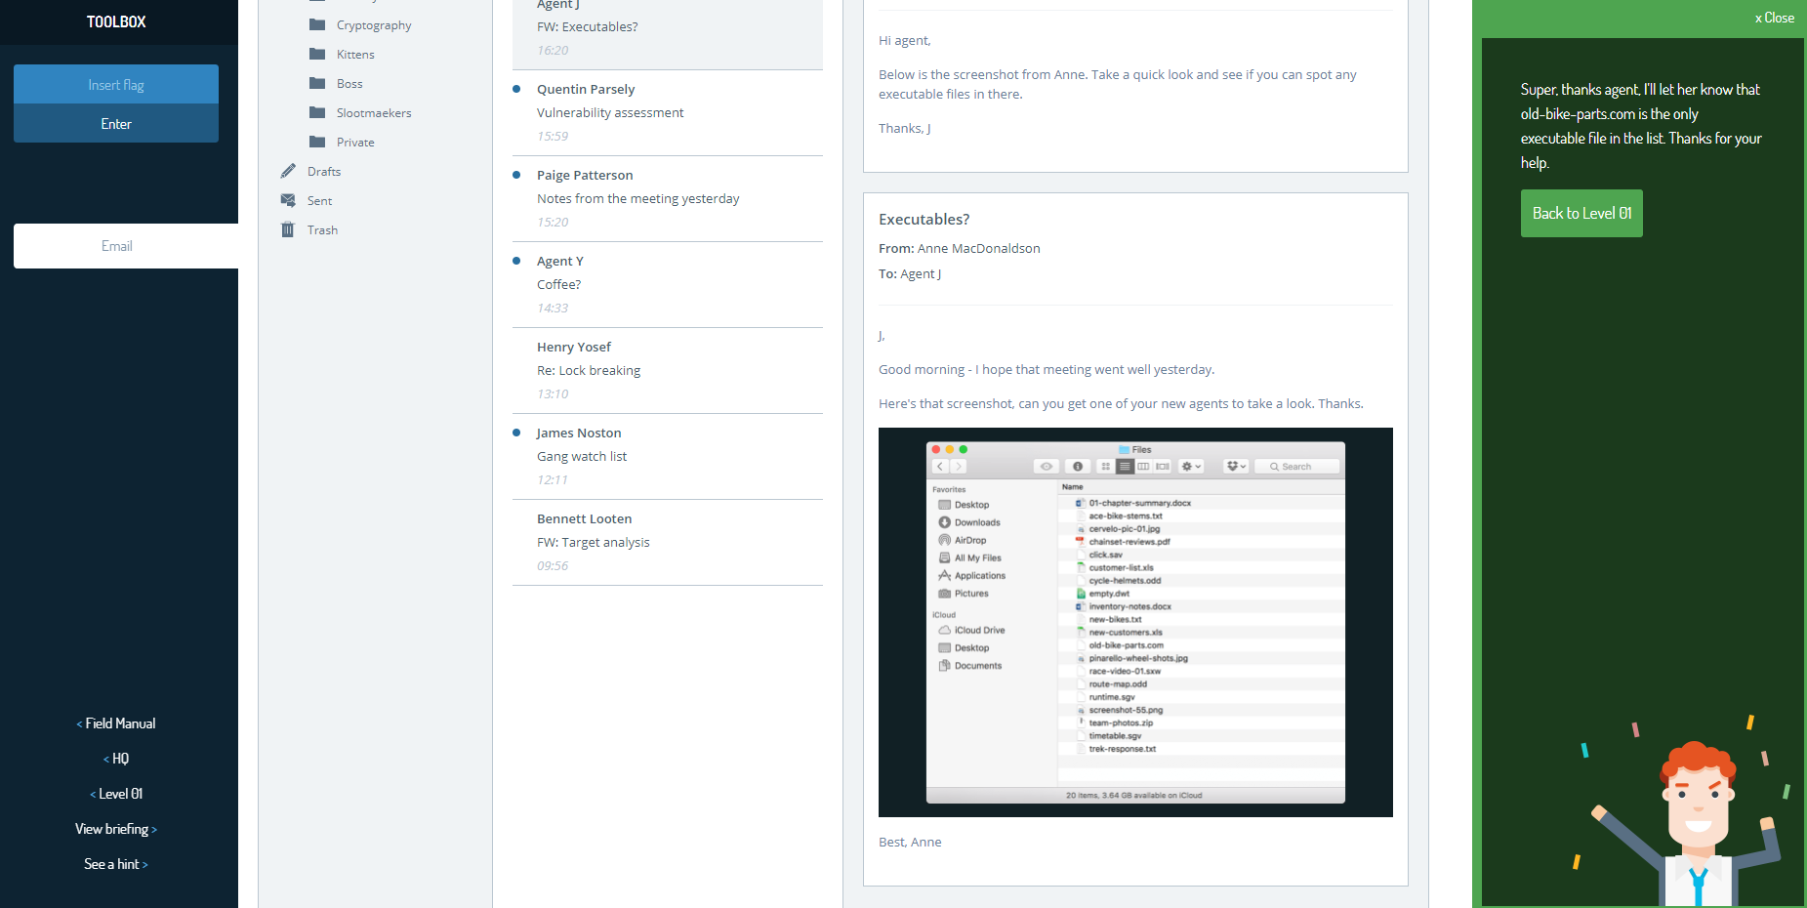

Challenge Name - X: Hidden Report - 11

Level of the Challenge: Easy

What was the challenge about?: Weblinks

What did you learn?: To change a url to access different pages

Your Interest Level: Interesting

Screenshot: 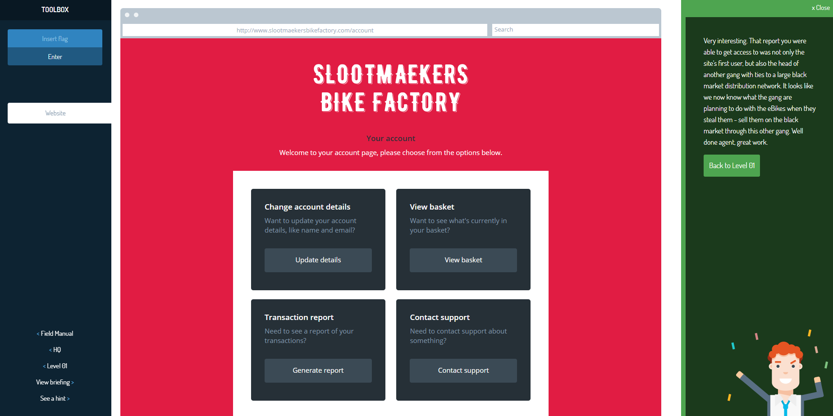

Challenge Name - X: Binary Bike Lock - 12

Level of the Challenge: easy

What was the challenge about?: Binary Codes

What did you learn?: To convert binary to numerical/ASCII and add

Your Interest Level: Not interesting

Screenshot: 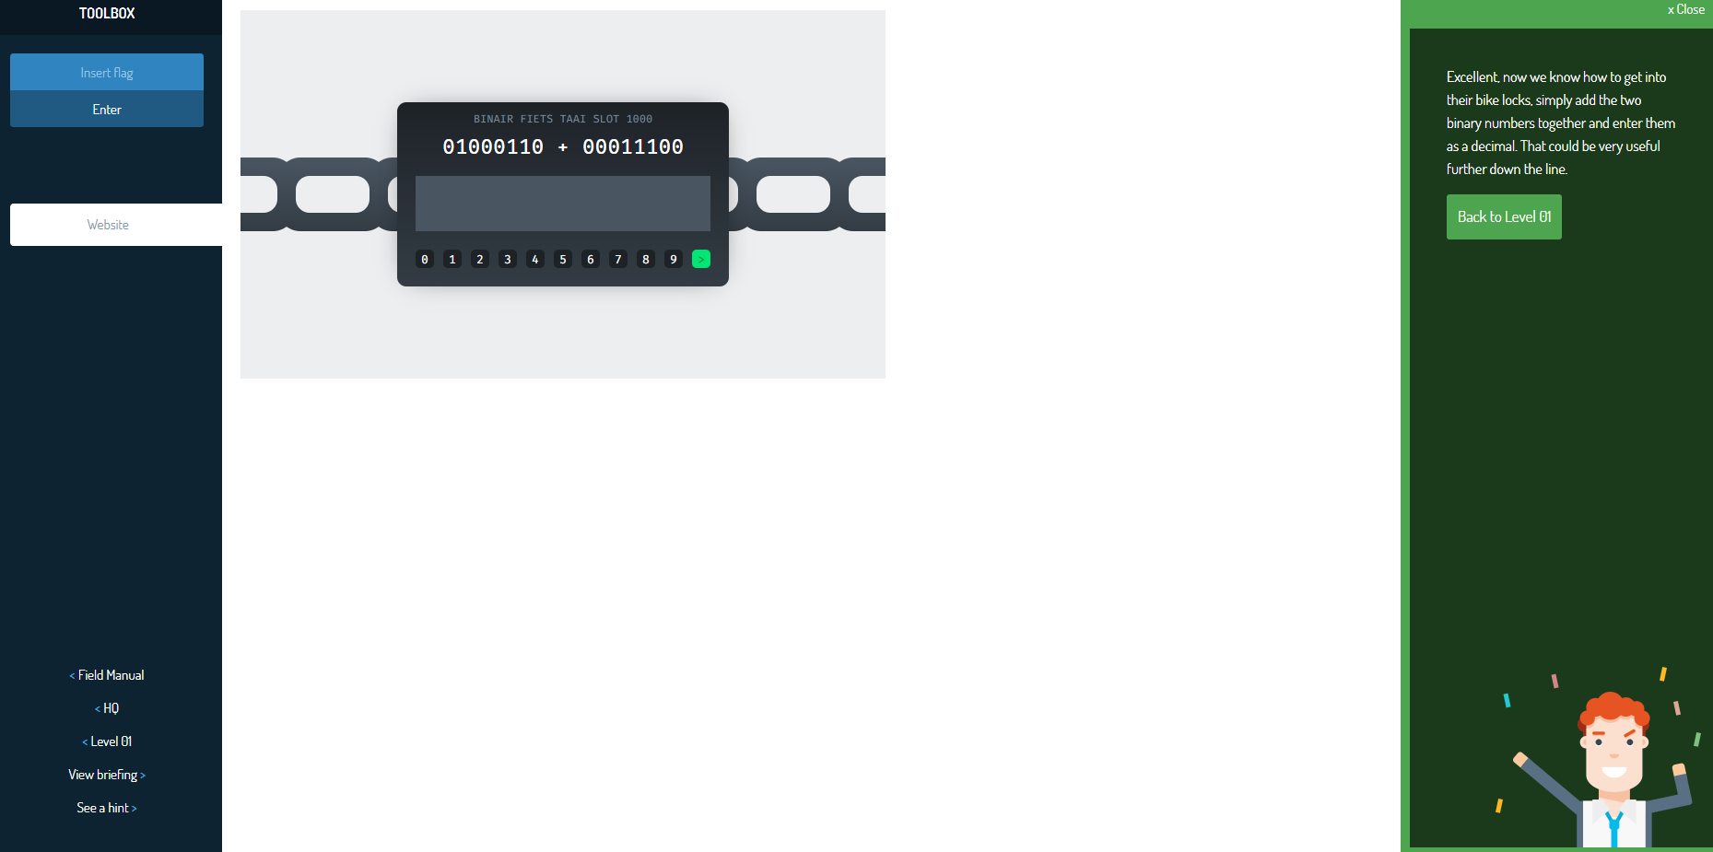

Challenge Name - X: User Who - 13

Level of the Challenge: Easy

What was the challenge about?: Linux username

What did you learn?: How to display who you are logged in as in linux

Your Interest Level: Interesting

Screenshot: 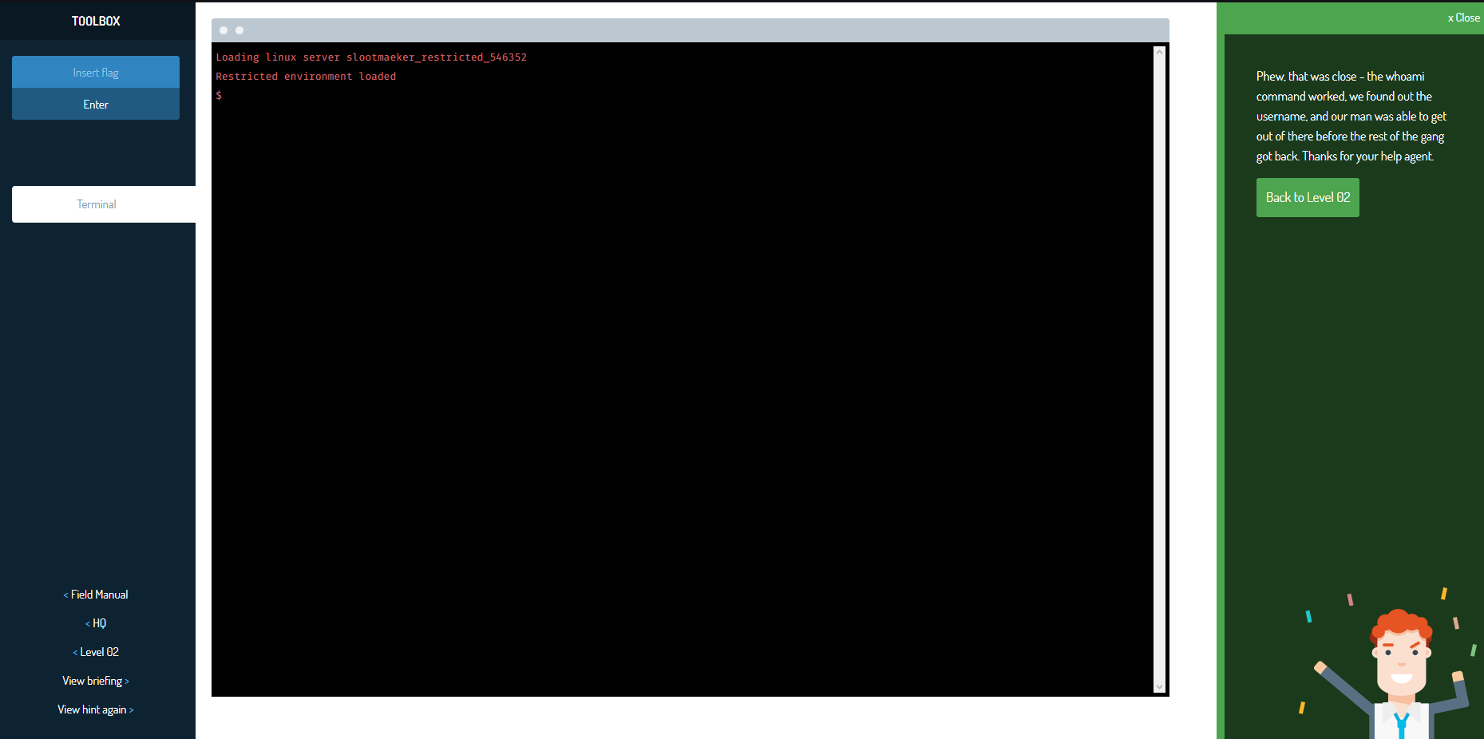

Challenge Name - X: Secret Pages - 14

Level of the Challenge: Easy

What was the challenge about?: Webpages

What did you learn?: Using URLs to display hidden pages

Your Interest Level: Interesting

Screenshot: 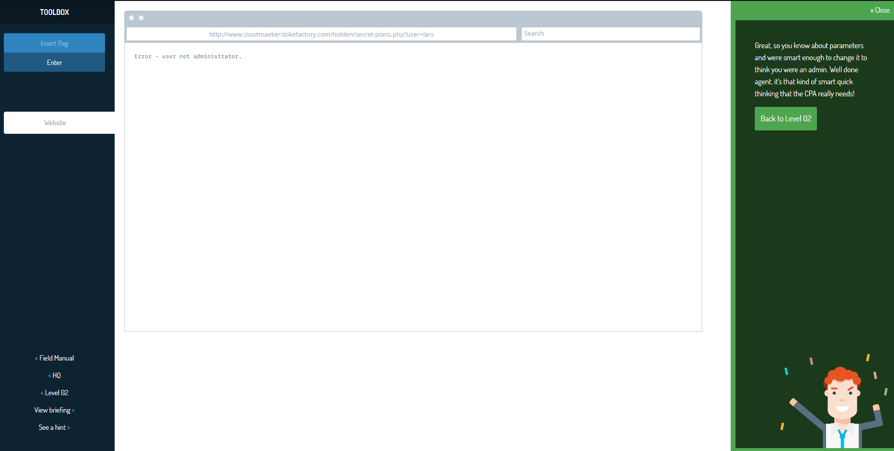

Challenge Name - X: Encrypted Message - 15

Level of the Challenge: Easy

What was the challenge about?: Caesar cipher

What did you learn?: Caesar cipher

Your Interest Level: Interesting

Screenshot: 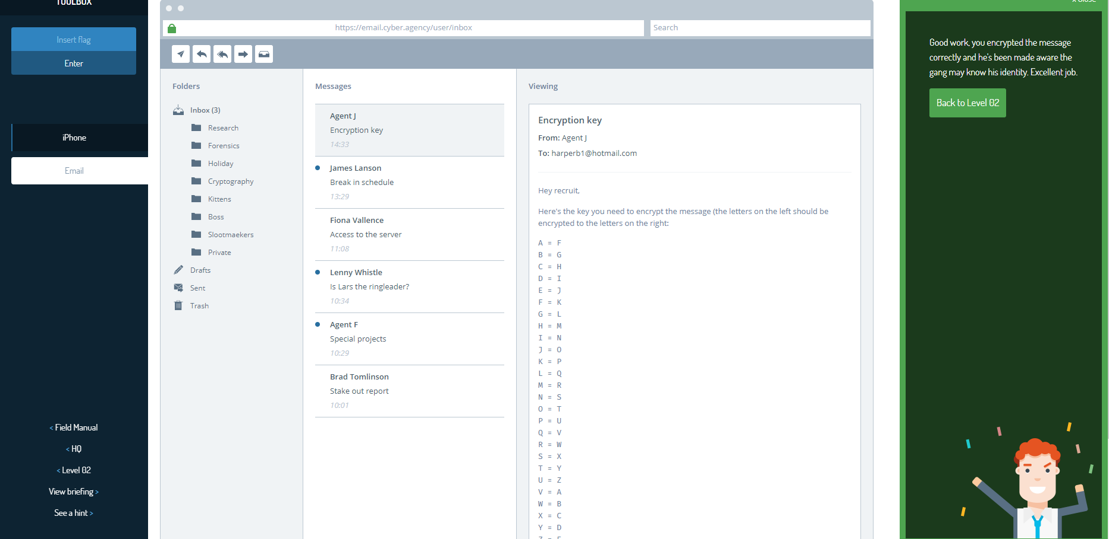

Challenge Name - X: Decryption Ring - 16

Level of the Challenge: Easy

What was the challenge about?: Caesar cipher

What did you learn?: Caesar cipher

Your Interest Level: Not Interesting

Screenshot: 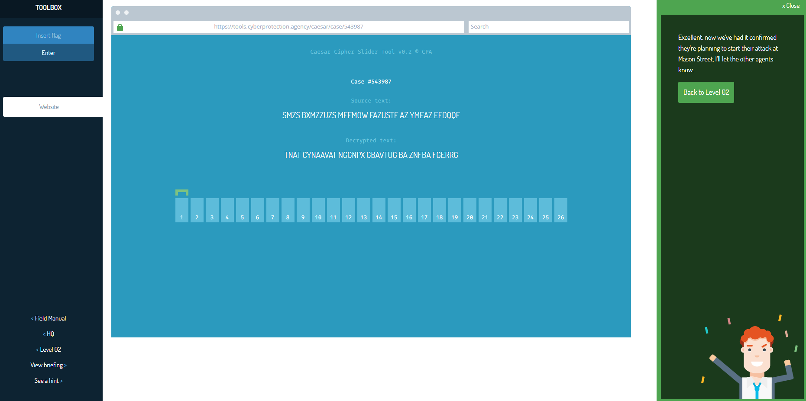

Challenge Name - X: Loopy Login - 17

Level of the Challenge: Easy

What was the challenge about?: Security flaws in websites

What did you learn?: Flaws in security on a website

Your Interest Level: Not Interesting

Screenshot: 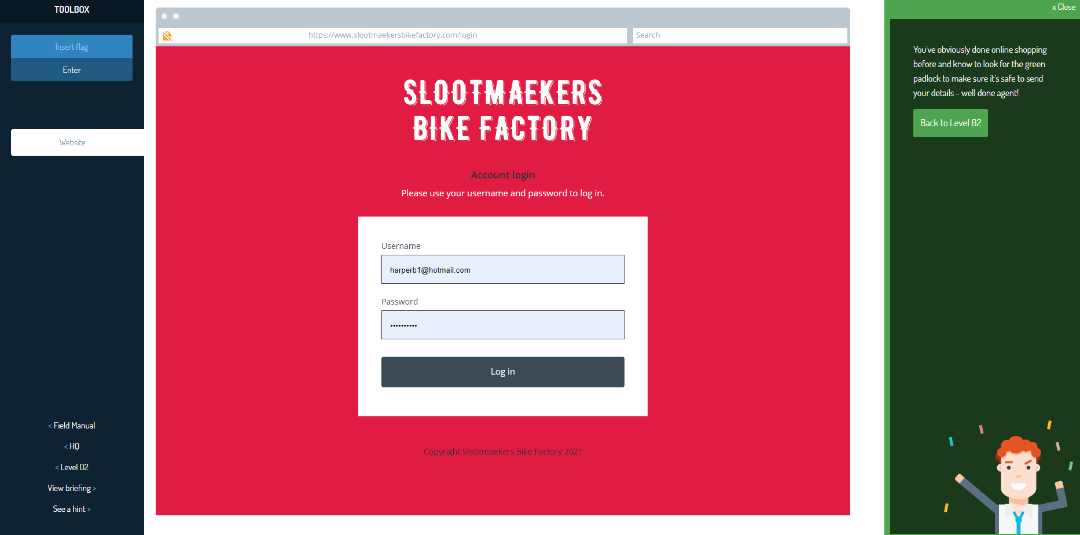

Challenge Name - X: Broken Click - 18

Level of the Challenge: Easy

What was the challenge about?: inspect element

What did you learn?: inspect element to repair a broken link

Your Interest Level: Interesting

Screenshot: 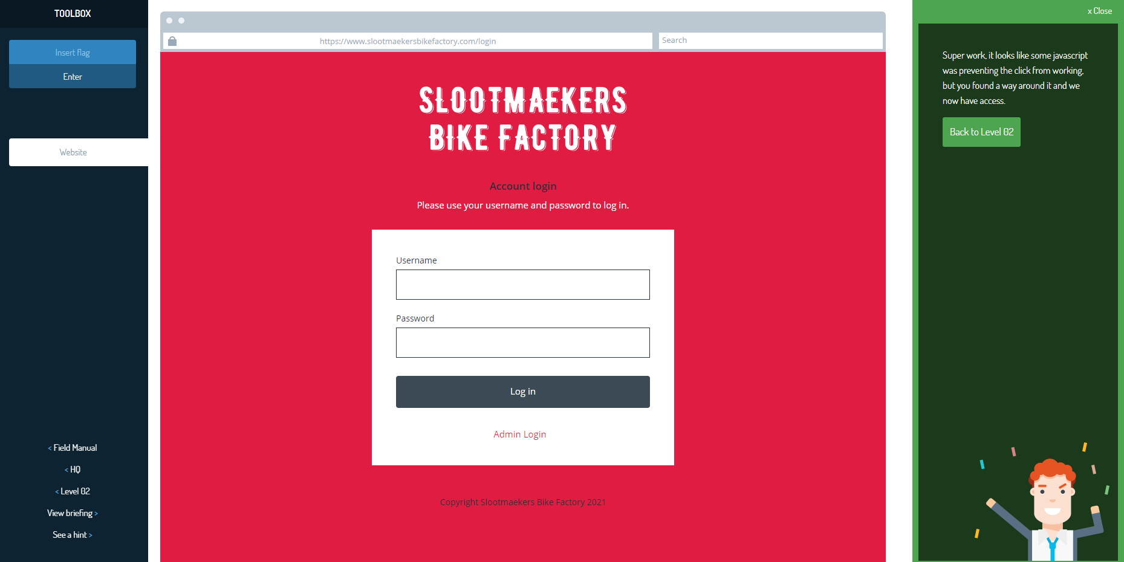

Challenge Name - X: Hard Hash - 19

Level of the Challenge: Easy

What was the challenge about?: Hashing

What did you learn?: hashing decoding

Your Interest Level: Interesting

Screenshot: 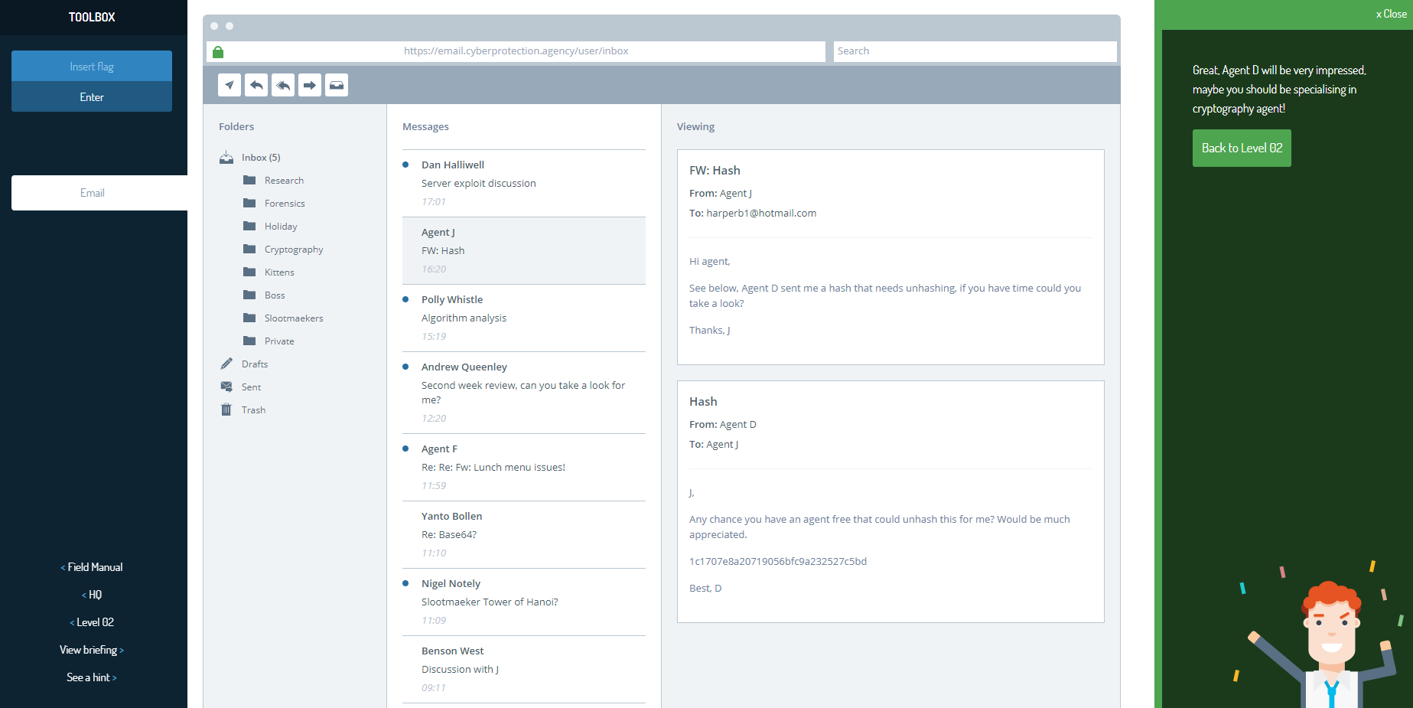

Challenge Name - X: More Broken Bicycles - 20

Level of the Challenge: Easy

What was the challenge about?: Repairing a link in a website

What did you learn?: Inspect element to fix a link to display an image

Your Interest Level: Interesting

Screenshot: 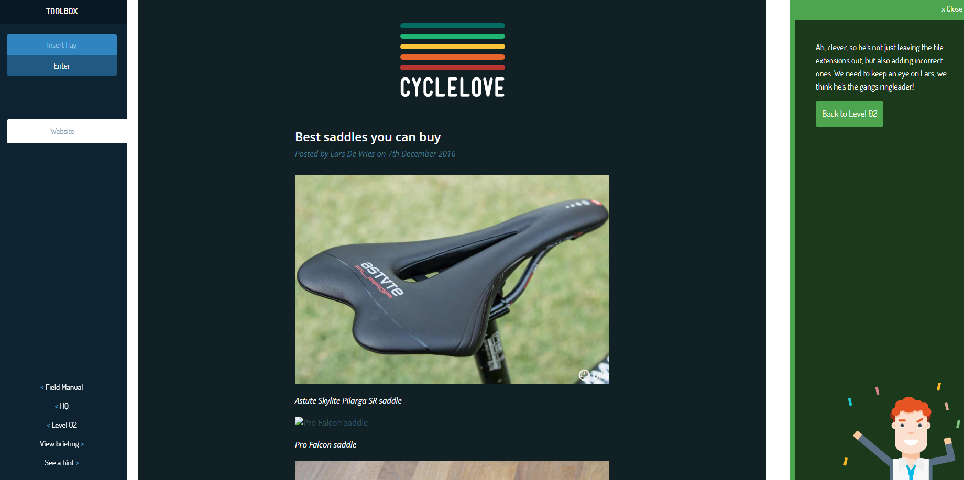

Challenge Name - X: Fingerprints - 21

Level of the Challenge: Easy

What was the challenge about?: Combinations without repetition

What did you learn?: using a permutation to find the password

Your Interest Level: Interesting

Screenshot: 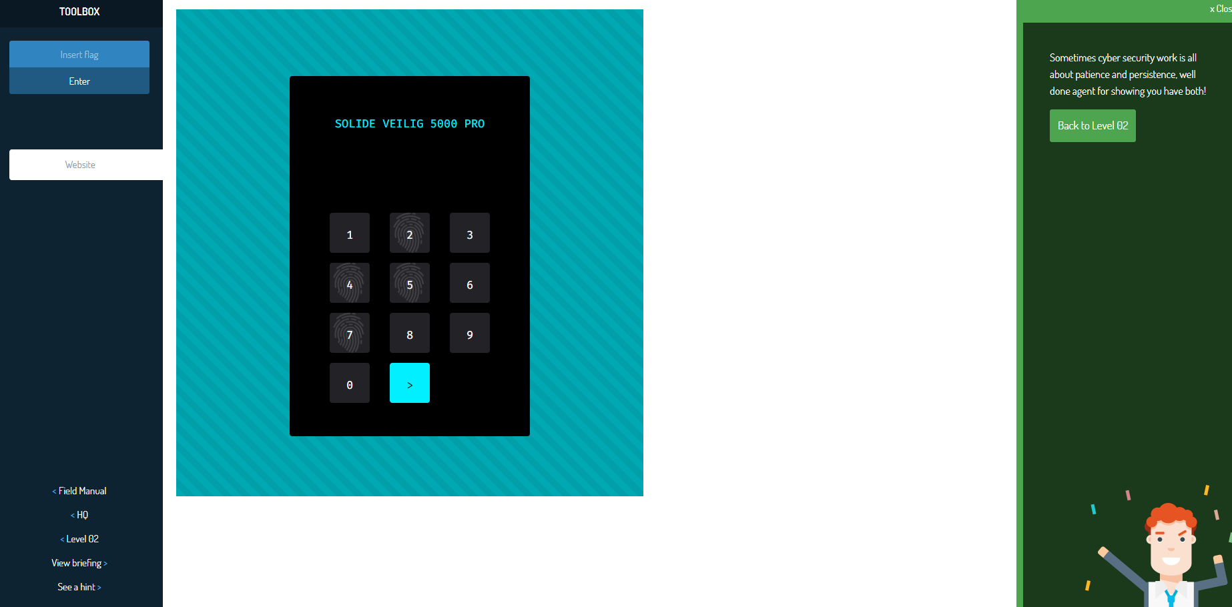

Challenge Name - X: Useful Hack - 22

Level of the Challenge: Easy

What was the challenge about?: using file dump to login

What did you learn?: using file dump to login with old usernames and passwords

Your Interest Level: Not Interesting

Screenshot: 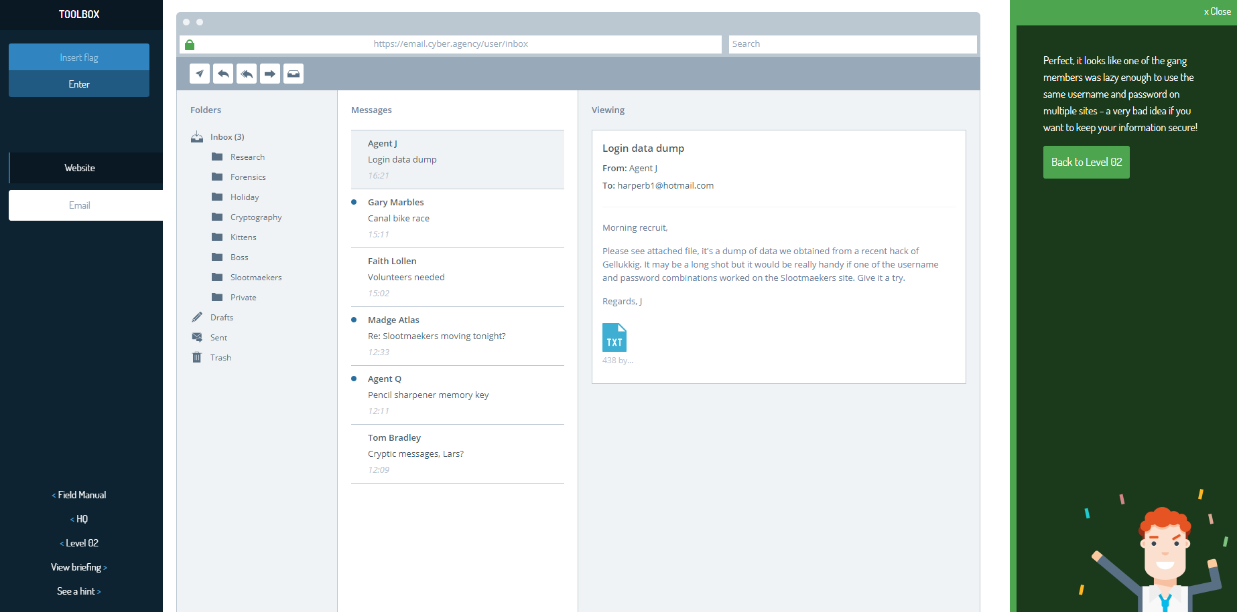

Challenge Name - X: Too Much Text - 23

Level of the Challenge: Easy

What was the challenge about?: searching text file for secrets

What did you learn?: ctrl + f to find code in text file

Your Interest Level: Interesting

Screenshot: 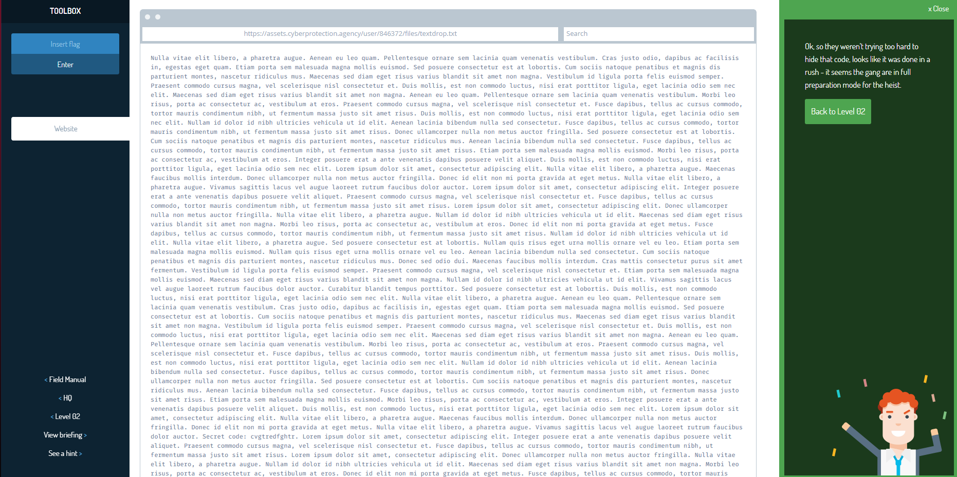

Challenge Name - X: Under Attack - 24

Level of the Challenge: Easy

What was the challenge about?: change server password settings

What did you learn?: proper password settings for a server

Your Interest Level: Interesting

Screenshot: 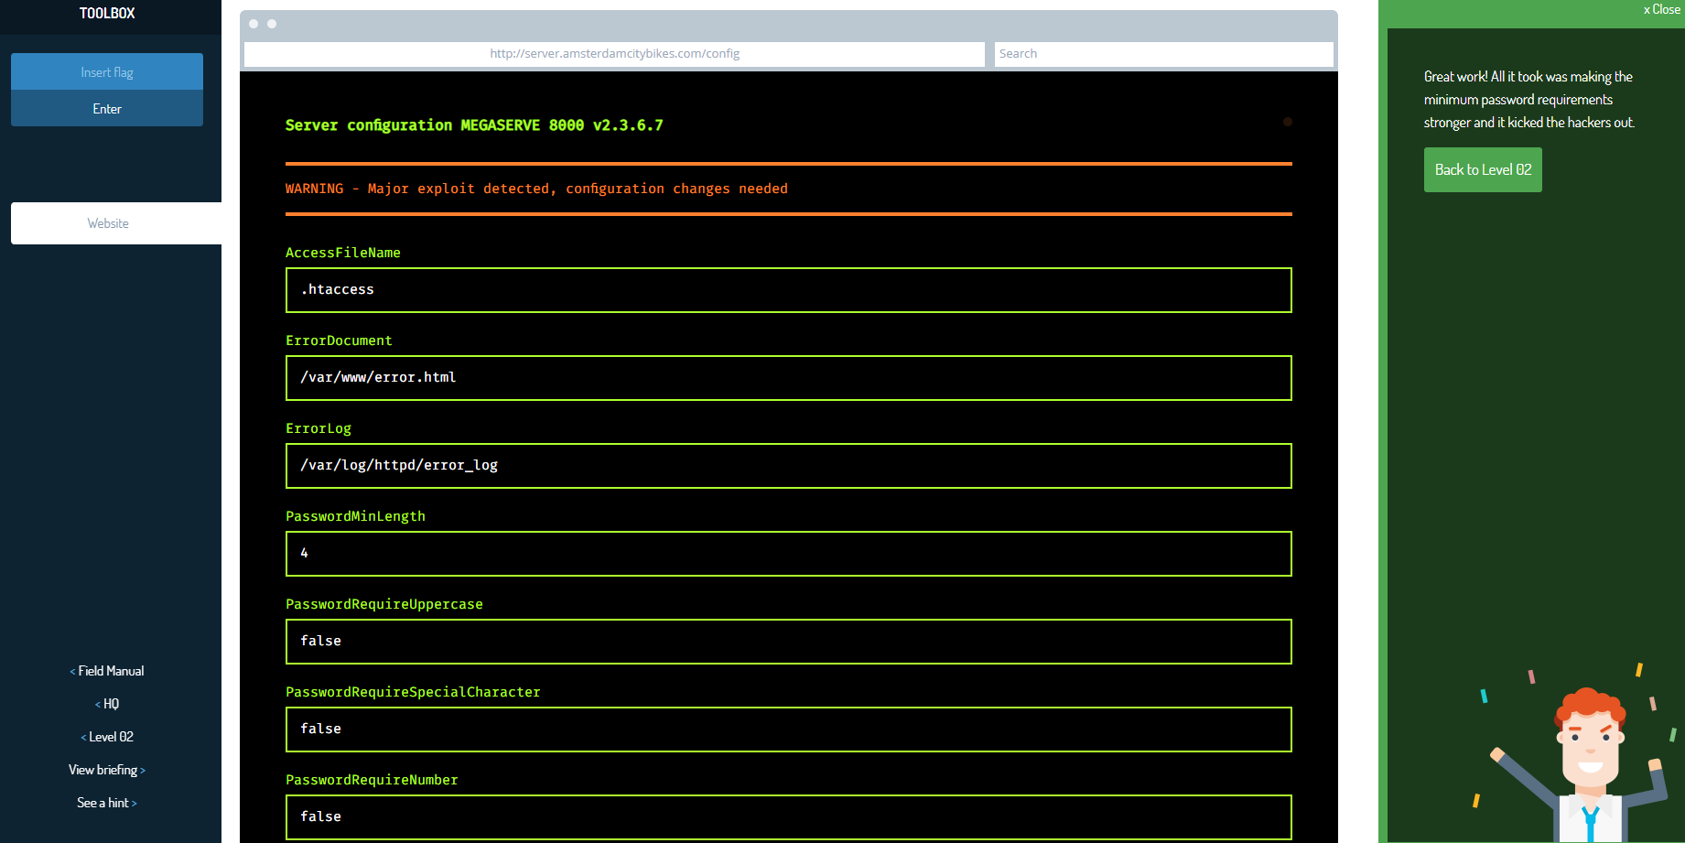

Challenge Name - X: Chopper Check-in - 25

Level of the Challenge: Easy

What was the challenge about?: find address based on users status updates

What did you learn?: people share too much info on the web

Your Interest Level: Interesting

Screenshot: 